Activity using SQLite Database:

NAME: A.PAVITHRA
REG NO: 192424347

1. Create the Department Table (Parent Table) with attributes Department_ID
INTEGER PRIMARY KEY, Department_Name TEXT

CODE:
import sqlite3

# Create or connect to the database
conn = sqlite3.connect("college.db")

# Create a cursor object
cursor = conn.cursor()

# Create Department table
cursor.execute("""
CREATE TABLE Department (
Department_ID INTEGER PRIMARY KEY,
Department_Name TEXT
)
""")

# Save changes
conn.commit()

print("Department table created successfully.")

# Display all tables in the database
cursor.execute("SELECT name FROM sqlite_master WHERE type='table';")
print(cursor.fetchall())

# Close the connection
conn.close()

OUTPUT:
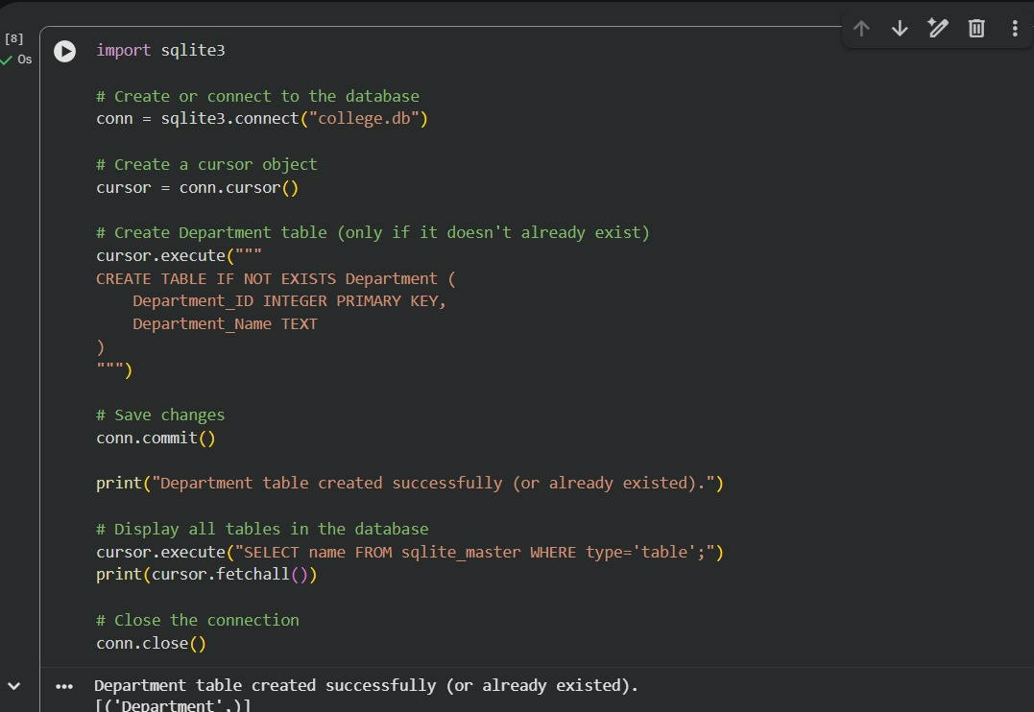

2. Create the Student Table (Child Table) with the following attributes:
Student_ID INTEGER PRIMARY KEY,
Name TEXT,
Age INTEGER,
Department_ID INTEGER,
CGPA REAL,
FOREIGN KEY (Department_ID) REFERENCES Department(Department_ID)

CODE:
import sqlite3

# Connect to the database
conn = sqlite3.connect("college.db")

# Enable foreign key support
conn.execute("PRAGMA foreign_keys = ON")

# Create a cursor object
cursor = conn.cursor()

# Create Student table
cursor.execute("""
CREATE TABLE Student (
Student_ID INTEGER PRIMARY KEY,
Name TEXT,
Age INTEGER,
Department_ID INTEGER,
CGPA REAL,
FOREIGN KEY (Department_ID) REFERENCES Department(Department_ID)
)
""")

# Save changes
conn.commit()

print("Student table created successfully.")

# Display all tables in the database
cursor.execute("SELECT name FROM sqlite_master WHERE type='table';")
print(cursor.fetchall())

# Close the connection
conn.close()

OUTPUT:
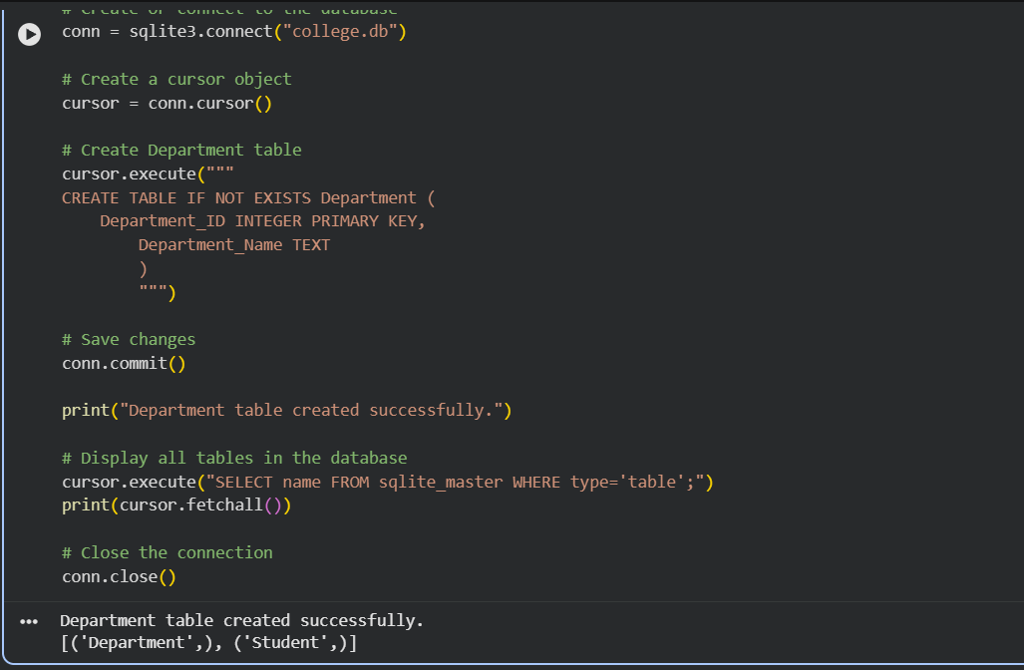

- Display students from CSE department.

CODE:
# Display students from CSE department

cursor.execute("""
SELECT Student.Student_ID,
Student.Name,
Student.Age,
Student.CGPA
FROM Student
JOIN Department
ON Student.Department_ID = Department.Department_ID
WHERE Department.Department_Name = 'CSE'
""")

rows = cursor.fetchall()

print("Students from CSE Department:")
for row in rows:
print(row)

conn.close()
OUTPUT:
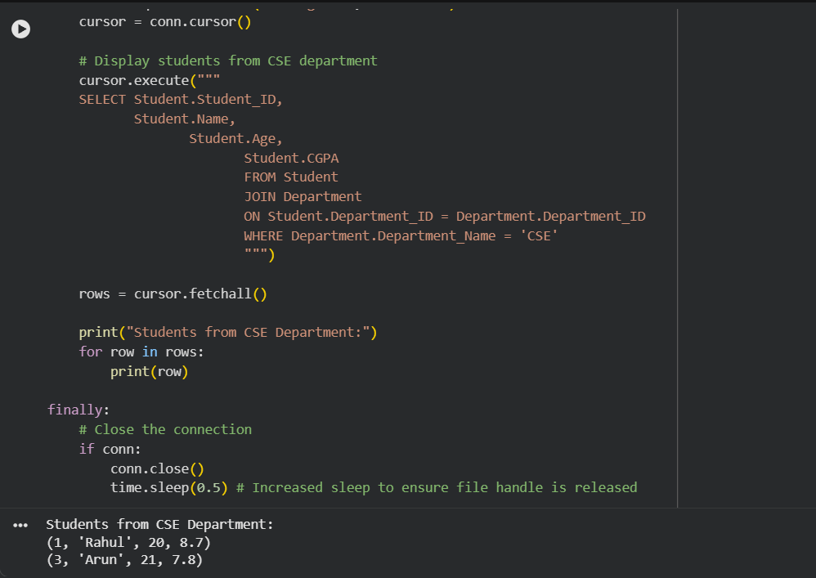

- Count students in each department.

CODE:
import sqlite3

# Connect to the database
conn = sqlite3.connect("college.db")
cursor = conn.cursor()

# Count students in each department
cursor.execute("""
SELECT Department.Department_Name,
COUNT(Student.Student_ID) AS Total_Students
FROM Department
LEFT JOIN Student
ON Department.Department_ID = Student.Department_ID
GROUP BY Department.Department_Name
""")

rows = cursor.fetchall()

print("Number of Students in Each Department:")
for row in rows:
print(row)

# Close the connection
conn.close()

OUTPUT:
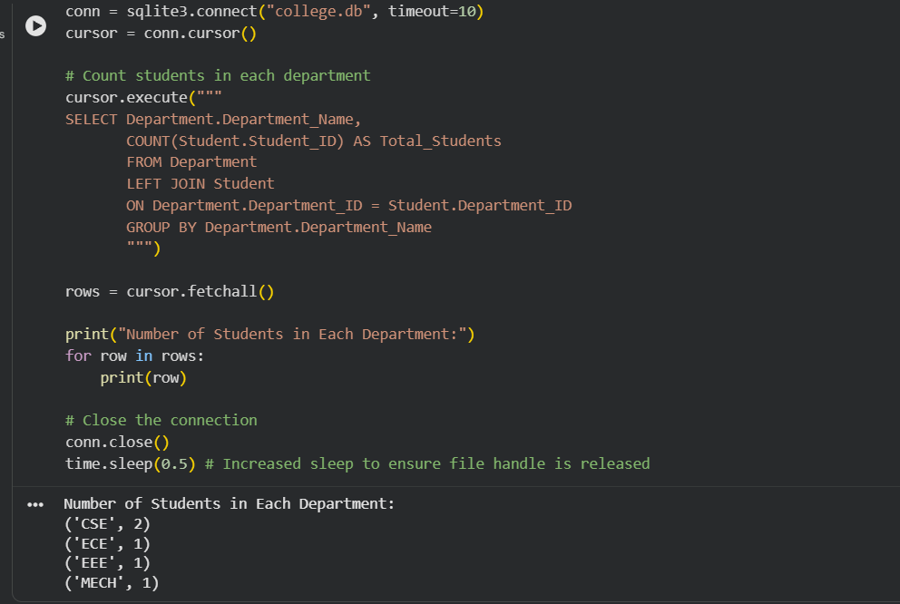

- Update the foreign key. For eg., change the department of a student

CODE:

import sqlite3

# Connect to the database
conn = sqlite3.connect("college.db")
cursor = conn.cursor()

# Update the student's department
# Change Rahul (Student_ID = 1) from CSE (101) to ECE (102)
cursor.execute("""
UPDATE Student
SET Department_ID = 102
WHERE Student_ID = 1
""")

conn.commit()

print("Student department updated successfully.")

# Display the updated student record
cursor.execute("""
SELECT Student.Student_ID,
Student.Name,
Department.Department_Name,
Student.CGPA
FROM Student
JOIN Department
ON Student.Department_ID = Department.Department_ID
WHERE Student.Student_ID = 1
""")

result = cursor.fetchone()
print(result)

# Close the connection
conn.close()

OUTPUT:
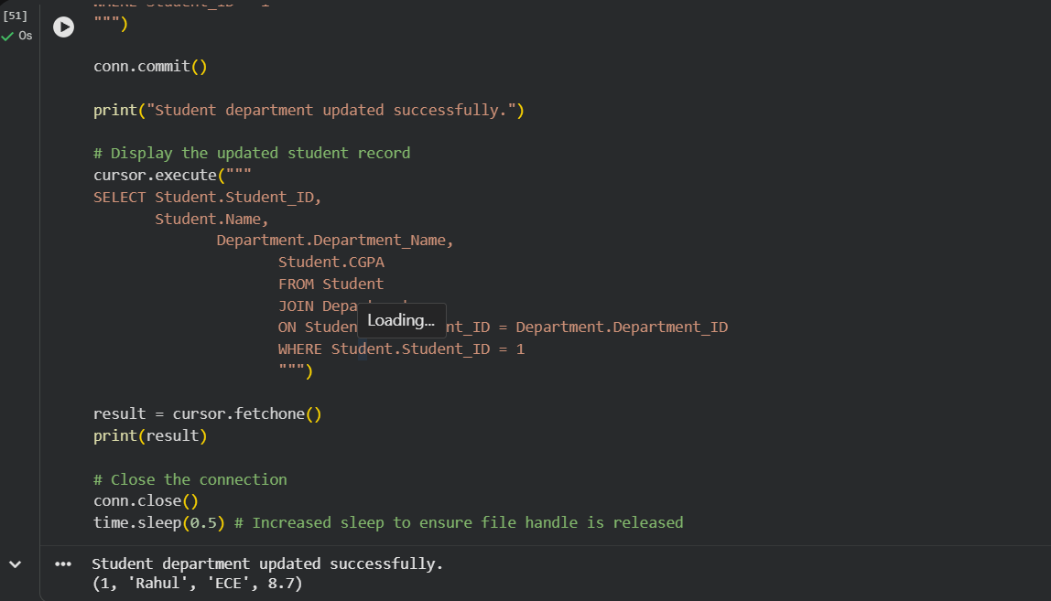

- Delete a department

CODE:
import sqlite3

# Connect to the database
conn = sqlite3.connect("college.db")

# Enable foreign key support
conn.execute("PRAGMA foreign_keys = ON")

cursor = conn.cursor()

# Delete the MECH department (Department_ID = 104)
cursor.execute("""
DELETE FROM Department
WHERE Department_ID = 104
""")

conn.commit()

print("Department deleted successfully.")

# Display the remaining departments
cursor.execute("SELECT * FROM Department")

rows = cursor.fetchall()

print("Remaining Departments:")
for row in rows:
print(row)

# Close the connection
conn.close()

OUTPUT:

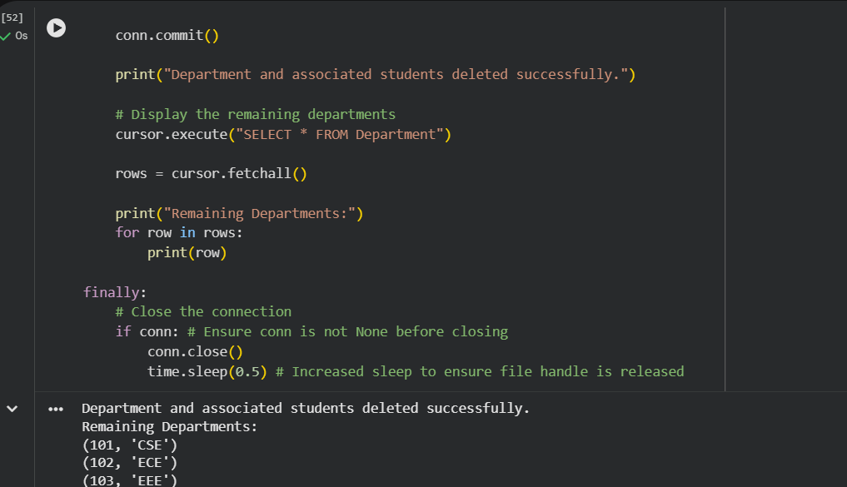

7. Display the student’s name, student’s department and CGPA if the student’s CGPA is
greater than 8.

CODE:

import sqlite3

# Connect to the database
conn = sqlite3.connect("college.db")
cursor = conn.cursor()

# Display students with CGPA greater than 8
cursor.execute("""
SELECT Student.Name,
Department.Department_Name,
Student.CGPA
FROM Student
JOIN Department
ON Student.Department_ID = Department.Department_ID
WHERE Student.CGPA > 8
""")

rows = cursor.fetchall()

print("Students with CGPA greater than 8:")
for row in rows:
print(row)

# Close the connection
conn.close()

OUTPUT:

